Syeda Reeha Quasar

14114802719

3C7

Experiment - 9

Switching Theory and Logic Design (STLD)

Aim

To realize 4-Bit Binary to BCD Convertor.

# **EXPERIMENT - 9**

## **AIM:**

To realize 4-Bit Binary to BCD Convertor.

## **Hardware and Software Apparatus Required**

Hardware:

Breadboard, IC 7400 (NAND), IC 7410 (3 input NAND), IC 7404(NOT), LEDs, 5V power supply, connecting wires.

Software Simulation:

The schematic models of the desired circuits will be stimulated on MULTISIM (Free Software), easily accessible at [www.multisim.com](http://www.multisim.com).

Components used – Source (Clock Voltage), Passive elements (resistor), Digital components (AND, OR, NAND, NOR, XOR, XNOR, Inverter), Probe for Analysis and annotation (Digital), Schematic connectors (Ground)

## **Theory:**

BCD is binary coded decimal number, where each digit of a decimal number is respected by its equivalent binary number. That means, LSB of a decimal number is represented by its equivalent binary number and similarly other higher significant bits of decimal number are also represented by their equivalent [binary numbers](https://www.electrical4u.com/binary-number-system-binary-to-decimal-and-decimal-to-binary-conversion/).

For example, BCD Code of 14 is-  
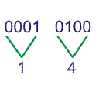Let us design a 4 bit **binary to BCD code converter**. As the 4 bit can represent 0 to 15, we can draw the conversion table as follows,  
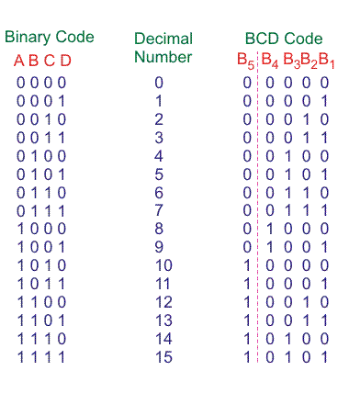

Here, B5 bit represents MSB of decimal number and B4, B3, B2, B1 represents 4 bit binary equivalent of LSB of decimal number.

From, above conversion table, we can write SOP form for different bits of BCD code.

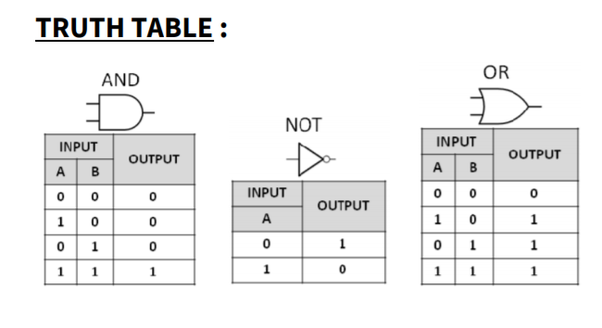

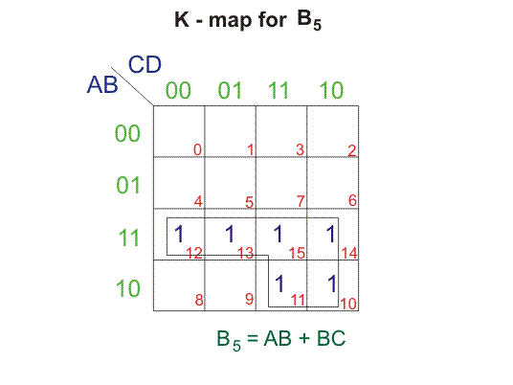  
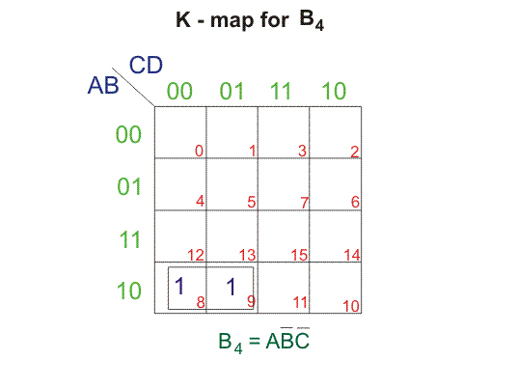  
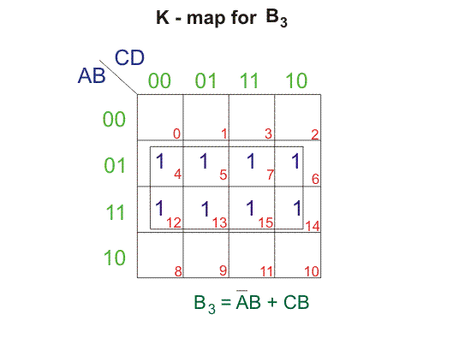  
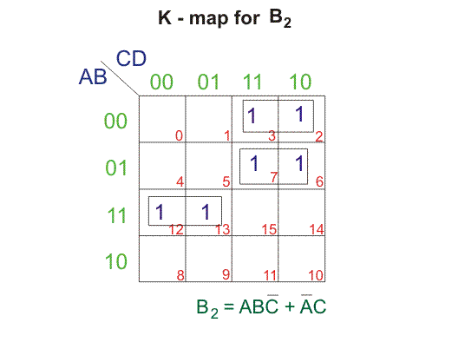  
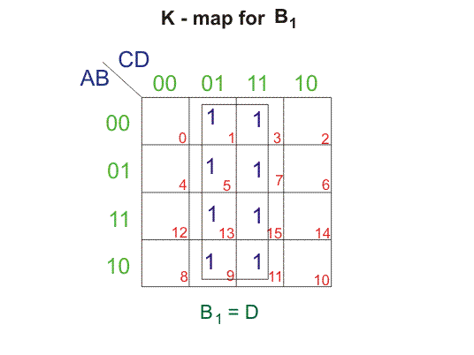  
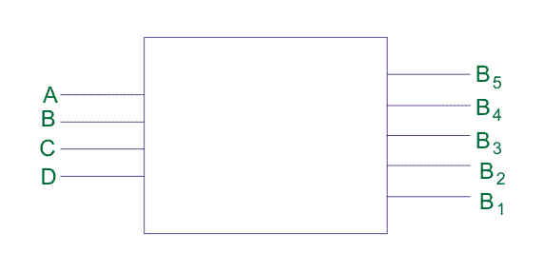

## **Procedure:**

1. Check all the components for their working.
2. Insert the appropriate IC into the IC base.
3. Make connections as shown in the circuit diagram.
4. Verify the results and observe the outputs.

Multisim:

1. Click on the ‘Create Circuit’ option on the top right corner of the profile in NI
2. Multisim webpage.
3. The schematic representation opens in a new tab.
4. Place three ‘Ground’ Schematic connector on the screen.
5. Place the logic gates from the digital section on the board, as per the
6. required circuit diagram for 4-bit Binary to BCD Converter
7. Now, add clock voltages to the input of the logic gate and connect them
8. with the help of Ground present in ‘Schematic Connectors’.
9. Change the frequency of clock voltages e.g V1(say=5kHz) and V2(say=3kHz)
10. etc.
11. Connect a resistor to the output of the logic gate and then, Ground it with
12. the help of Ground Schematic Connector.
13. Connect the components with connecting wires.
14. Add digital probes to both input and output connections.
15. Set the display to ‘Transient’ from Interactive and press the ‘Start
16. Simulation’ button.
17. Note the graph

## **PRECAUTIONS:**

1. All ICs should be checked before starting the experiment.
2. All the connection should be tight.
3. Always connect ground first and then the supply.
4. Switch off the power supply after completion of the experiment.

## **RESULT:**

4-Bit Binary to BCD Convertor has been studied and its truth table is verified.

**Circuits and Output waveform**

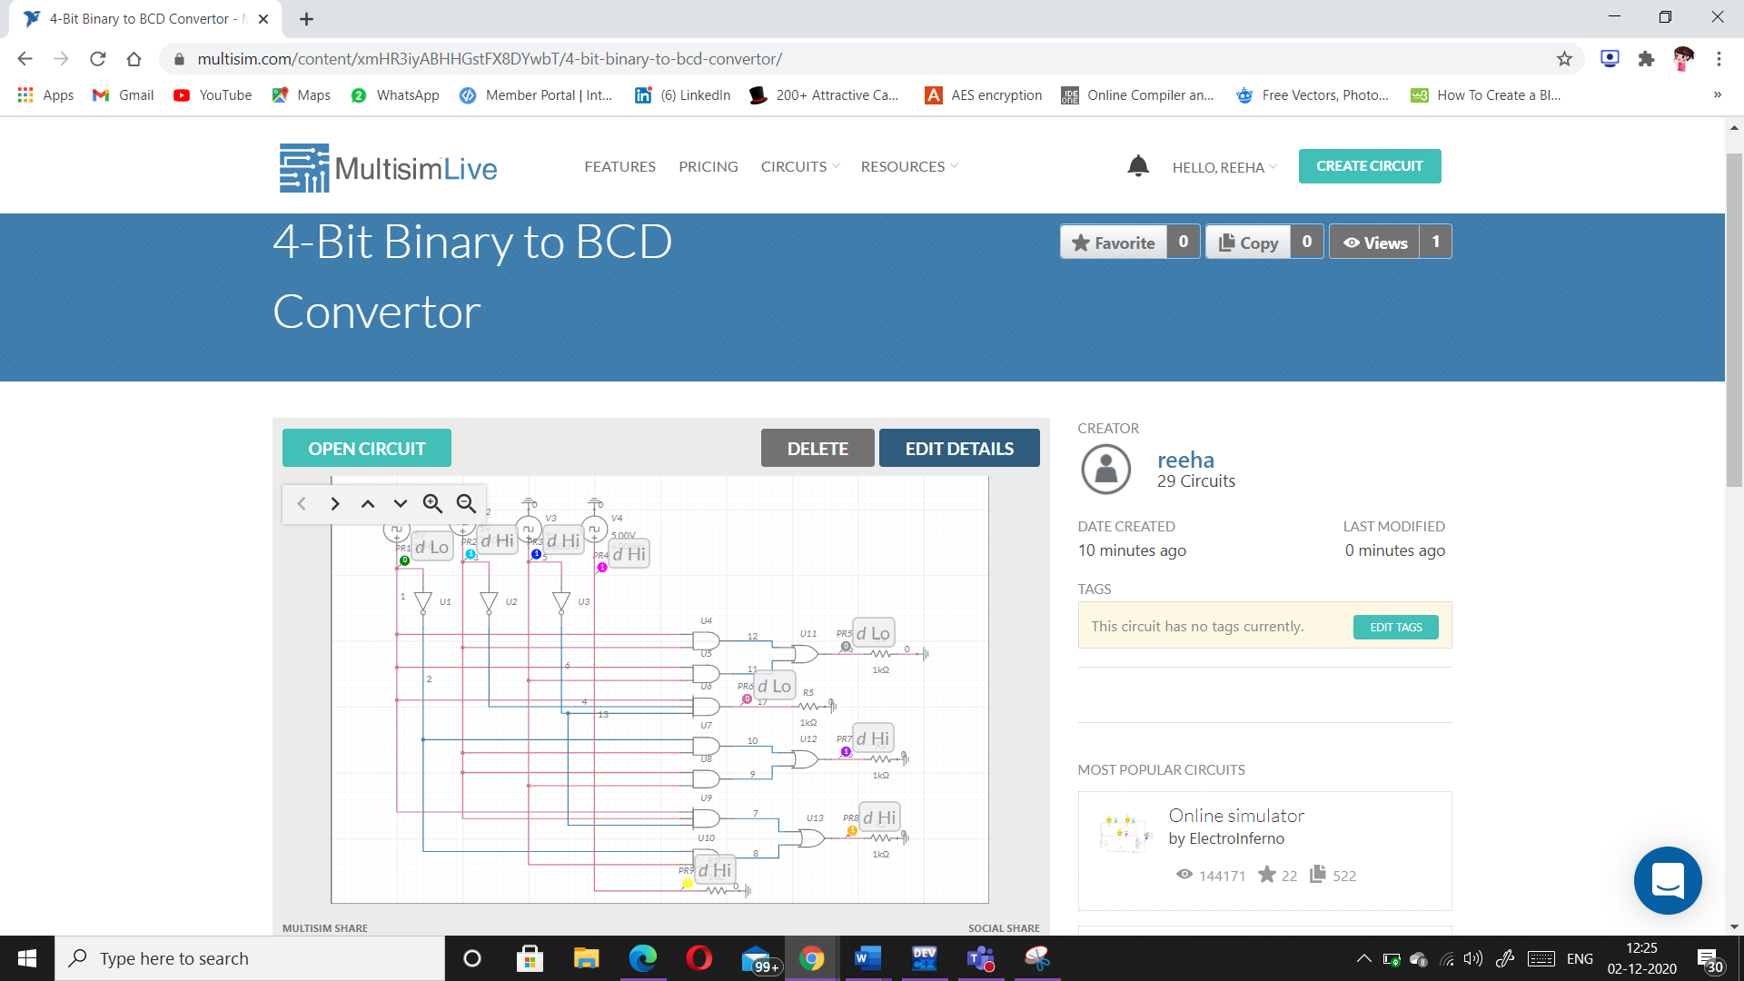 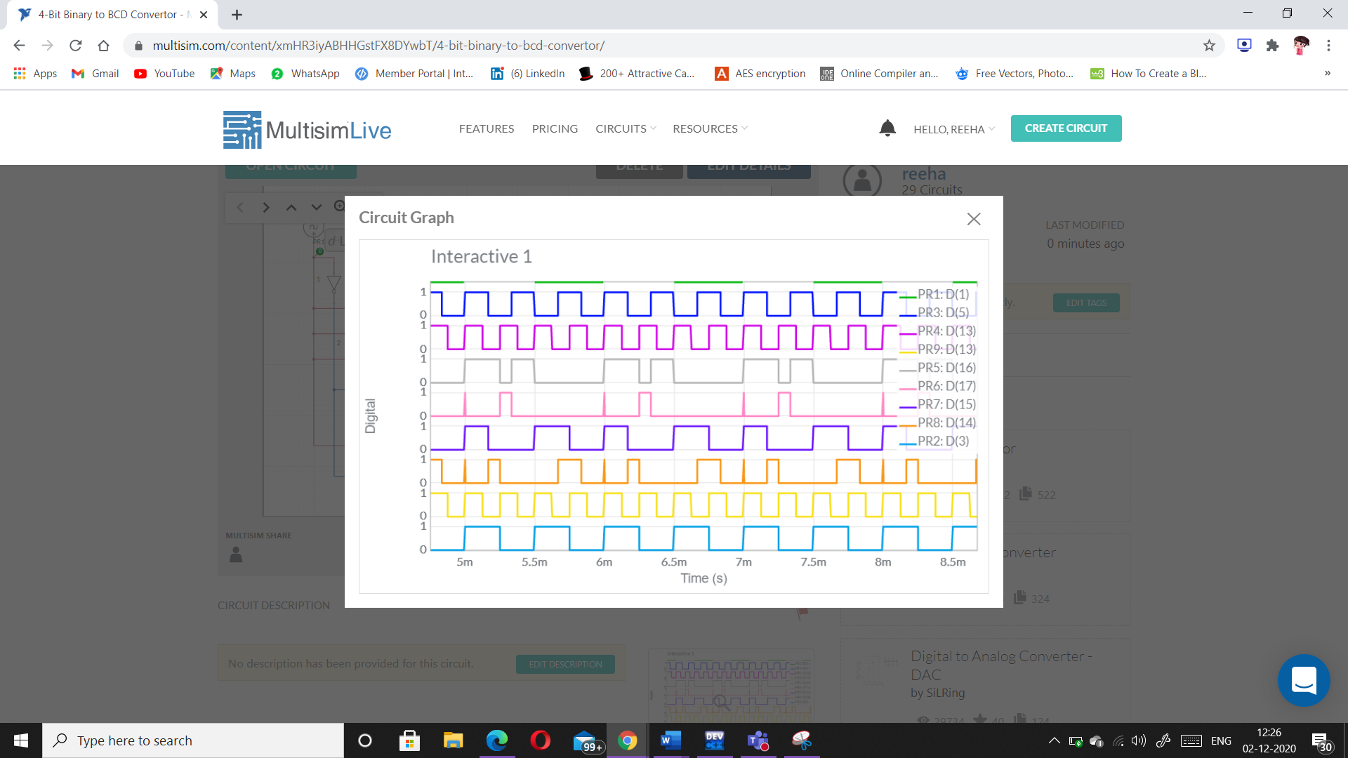

# **VIVA-VOCE QUESTIONS:**

1. **(10110)2 = ( ? )BCD**

Ans.

(10110)2 = (_______)BCD

|  |  |
| --- | --- |
| 2 | 2 |
| 0010 | 0010 |

1. **Convert decimal to BCD** **(22)10 = (_______)BCD**

∴ (22)10 = (00100010)BCD  
  
  
**∴ (10110)2 = (00100010)BCD**

1. **Write the algorithm to convert binary to BCD.**

Ans.

**Algorithm:**

1. If any column (100's, 10's, 1's, etc.) is 5 or greater, add 3 to that column.
2. Shift all #'s to the left 1 position.
3. If 8 shifts have been performed, it's done! Evaluate each column for the BCD values.
4. Go to step 1.

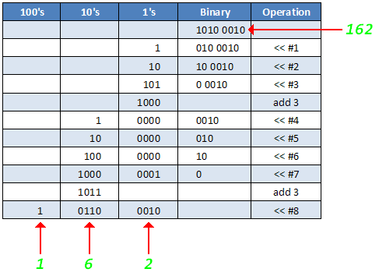

1. **Why do we convert Binary to BCD?**

Ans.

|  |  |
| --- | --- |
|  | Conversion of a binary number into separate binary numbers representing digits of the decimal number. *(this example is for 8-bits, other sizes follow the same pattern)* |

